**LAB 1 TASK**

**Task 3 - Run a test program in console window by changing the value of EAX in line 5 to 8600h**

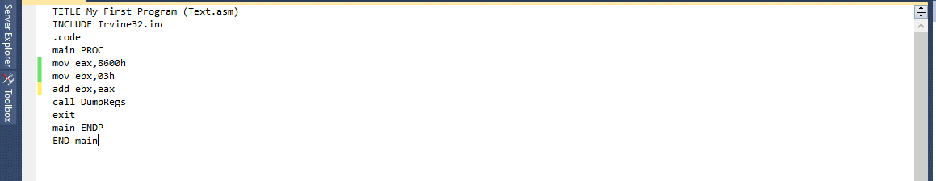

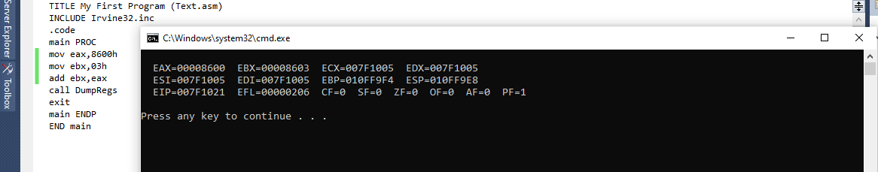

**TASK 4: Debug your program and note down the value of EAX after the execution of each line.**

ANS: First the value will be default which is **EAX=006FFD60**, then after executing value would be **EAX=00008600** after then value for EAX will be same until the program ends.

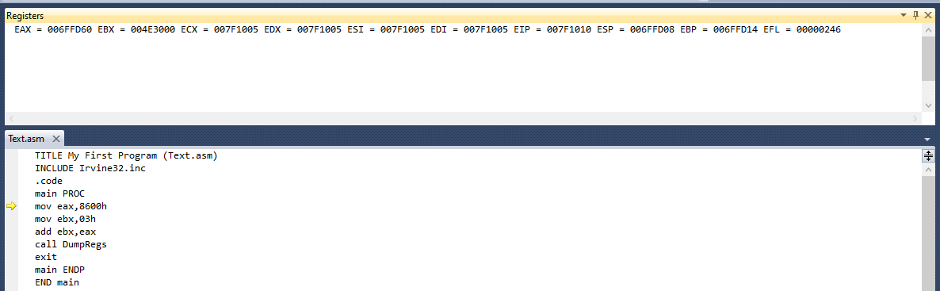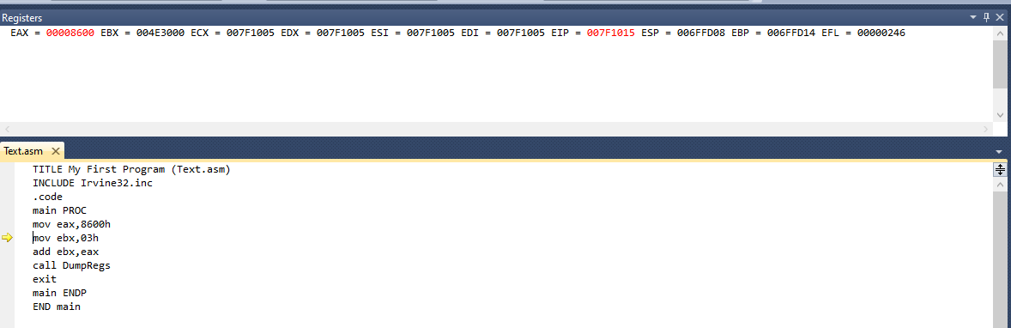

**Task 5 - Fill in the following table with the offsets of the instructions in the code segment.**

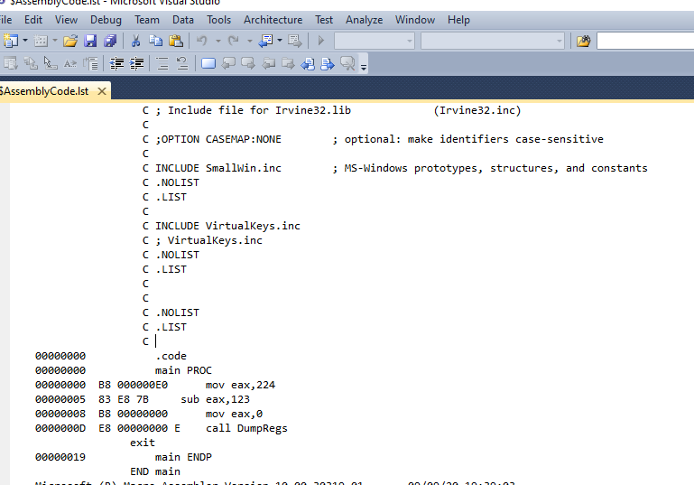

|  |  |
| --- | --- |
| Offset | Instructions |
| 00000000 B8 000000E0 | mov eax, 224 |
| 00000005 83 E8 7B | sub eax, 123 |
| 00000008 B8 00000000 | mov eax, 0 |
| 0000000D E8 00000000 E | call DumpRegs |
| 00000019 | Main ENDP |

**Task 6 - Explain the purpose of listing file.**

The main purpose of listing file is that if there is any error in source file, then it will not create any object file.

**Task 7 - Name four software tools used for assembly language programming:**

* Editor
* Assembler
* Linker
* Debugger

**Task 8 - What is an assembler?**

An assembler is a program that converts source-code programs written in assembly language into object files i.e machine language code

**Task 9 - What is a linker?**

A linker is a program that combines your program's object file created by the assembler with other object files and link libraries, and produces a single executable program.

**Task 10 - What is a debugger?**

Debugger identifies bugs and logical programming errors during execution

**Task 11 - Write a Program that subtract two number in Hex**





